Isuzu Motors Co., (Thailand) Ltd.

RT50 Frame Line
Line Monitoring System (LMS)
OPERATION MANUAL

OMRON
Contents
RT50 Frame Line LMS System 1
1. Introduction 1
Software Functions 1
LMS Server 1
LMS Client 2
2. LMS Server 3
3. LMS Client 7
Shut Down the System 8
4. LMS Client – Monitoring 9
Description 9
Switch to the other monitoring screen 10
ALL-Lines Monitoring Screen 11
Use or No Use Status 11
FATS Status 11
CPT Line Monitoring Screen 13
M/A Line Monitoring Screen 14
M/C Line Monitoring Screen 15
S-M/A Line Monitoring Screen 16
S-M/B Line Monitoring Screen 17
S-M/C Line Monitoring Screen 18
FATS Upper Monitoring Screen 19
FATS Lower Monitoring Screen 20
P/P Board Monitoring Screen 21
Back to Main Menu 21
5. LMS Client – Schedule Set 22
Description 22
Import Plan File 24
Edit Plan 26
Pattern Set 29
6. LMS Client – Log Data 31
Description 31
Alarm List Report 34
Welding Data Report 36
P/P Board Report 39

RT50 Frame Line LMS System

Introduction
Line Monitor System (LMS) is a system for monitoring the frame line equipments status, production operation and getting the result of welding data. The system includes the software both on server and client computer. The LMS Server software will be installed on the server computer for getting status and production result data from PLC, record the result into the database and send the production result to the production board. The LMS Client software is the end-user interface software shows the line status monitoring data, import production plan and print out the status or production result.
The Frame Line production include the following lines below
- CPT Line
- M/A Line
- M/C Line
- S-M/A Line
- S-M/B Line
- S-M/C Line
- FATS Line

Software Functions

LMS Server
LMS Server is the Server-side software installed on the PC Server machine. The main function is the communicate data between PLC and database, calculate the production target and send the result to the production board. The below list will shown the functions of LMS Server
- Getting alarm data from PLC and record alarm or fault status into database
- Getting the equipment status, includes the Lifter, Robot, State and others, then record the current status into database for LMS Client will retrieve these data for show the status on the client software screen
- Getting the Sequence Number from each Frame Line equipments
- Getting the actual production result, calculate the balance and ratio and sending the result to production board
- Getting the welding data from the production line and record into the database.
- Check communication status between the PC Server and PLC.

LMS Client
LMS Client is the Client-side software installed on the PC Client machine. The main functions are the end-user interface by GUI for showing the line monitoring status and getting production plan by import file, finally the software can show the result or line status and production. The below list will shown the functions of LMS Client
- Monitoring
  - Show the Line Monitoring status includes the Equipment Status (States, Lifters and Robots and FATS) for all lines in overview mode.
  - Show the Line Monitoring status includes the Equipment Status (State, Lifter, Robot) in details in each production line, the screen will also show the Sequence Number and Alarm Details
  - Show the Current Production Board Data
- Schedule Set
  - Show the daily schedule production plan
  - Import Production Plan from Ms. Excel files (Ms. Excel 2003 file format)
  - Modify the production plan
  - Set the Pattern of Production
- Log Data
  - Show the report of alarm
  - Show the report of welding data
  - Show the report of production

LMS Server
LMS Server is the all time software running on the PC Server computer. After start up the Ms. Windows Server this program must be automatically started. The LMS Server software periodically gets monitoring data from PLC, calculate of production, record monitoring data into database and send the production result to production board.
In case of the LMS Server not yet start or was terminated, user can double click the icon on the desk top as Figure 1-1
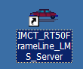
Figure 2-1 Desktop Icon for LMS Server

After the LMS Start the main screen will be shown as Figure 2-2

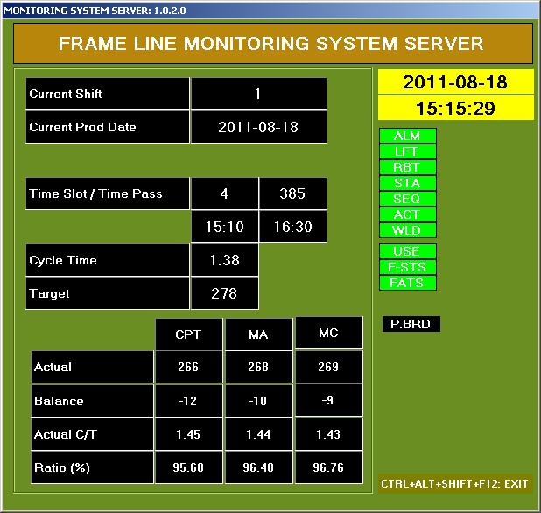
A
B
C
D
F
G
E
Figure 2-2 Main screen of LMS Server

Part A Current Shift and Current Production Date
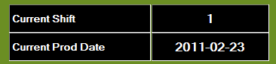
Current Shift | Current Time Shift Number (1=Day Shift, 2=Night Shift)
Current Prod Date | Current Time Production Date

Time Slot Number
Time Pass
Part B Time Slot, Time Pass
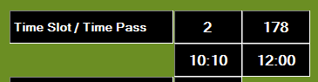
Start Time
End Time

Time Slot Number | Time slot number by pattern of schedule setting (the number is 1..7)
Time Pass | The number minutes of start shift to the current time
Start Time | Start time of current time slot
End Time | End time of current time slot

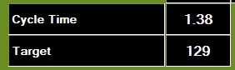
Part C Cycle Time and Target

Cycle Time | Production plan cycle time
Target | Current time target of production unit (automatically calculated)

Part D Actual Production, shown the actual production data of each line (CPT, M/A and M/C line)
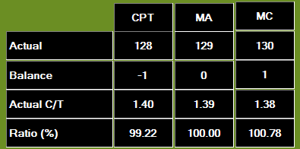

Actual | Actual production unit from PLC
Balance | Difference value between Current Time Target and Actual
Actual C/T | Calculate from actual unit data compare with the current time pass
Ratio (%) | Productivity ratio of actual production data

Part E Current Date and Time
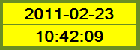
Show the Current Date and Time

Part F Process Lamp Indicator
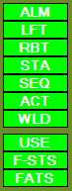
Show lamp Indicator of each process. First time all lamp will be off (black color) when the software start process of each part (for example ALM that means the process of alarm data) in case of process successful the lamp will be on (green color) but in case of process failure the lamp will not yet show on status (be still black color.)
Process of alarm data
Process of Lifter status
Process of Robot status
Process of station status
Process of sequence number
Process of actual production unit data
Process of welding data
Process of Use status
Process of FATS status in overall
Process of FATS status in details of each equipments
Process of sending the result to production board, for a time of sending data, this lamp will be flash to green color in a short time and back to black color, in case of failure of sending data to the Production Board the lamp will show the red lamp

Part G Other Indicator
In normal case this part will show only the label of how to exit program (by press the combination keys CTRL+ALT+SHIFT+F12). In case of the communication of server and gateway PLC is loss or something wrongs the indicator will be shown at the right-bottom of screen as below.
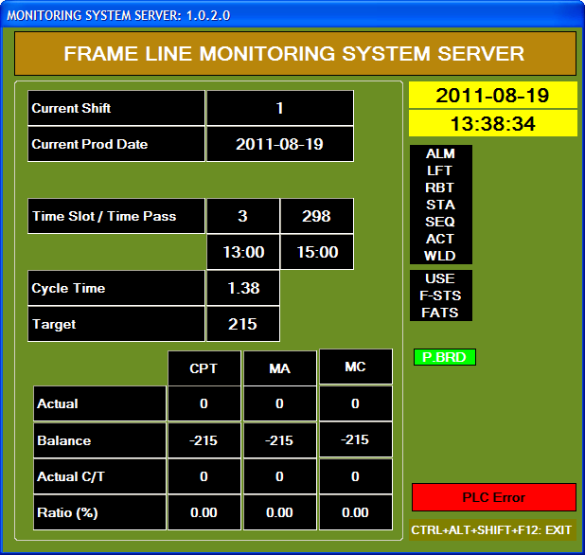

LMS Client
LMS Client is the user-interface software which contains the GUI (Graphical User Interface) show the status and information of Frame Line Monitoring data. User can import the production plan from Ms. Excel file (Ms. Excel 2003 format) and can edit the plan, set pattern and show the report of production or alarm data.
Start the LMS Client software by click the icon in the desktop as Figure 3-1.
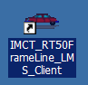
Figure 3-1 LMS Client Icon on the desktop

After start up the LMS Client, the main menu will be shown as Figure 3-2
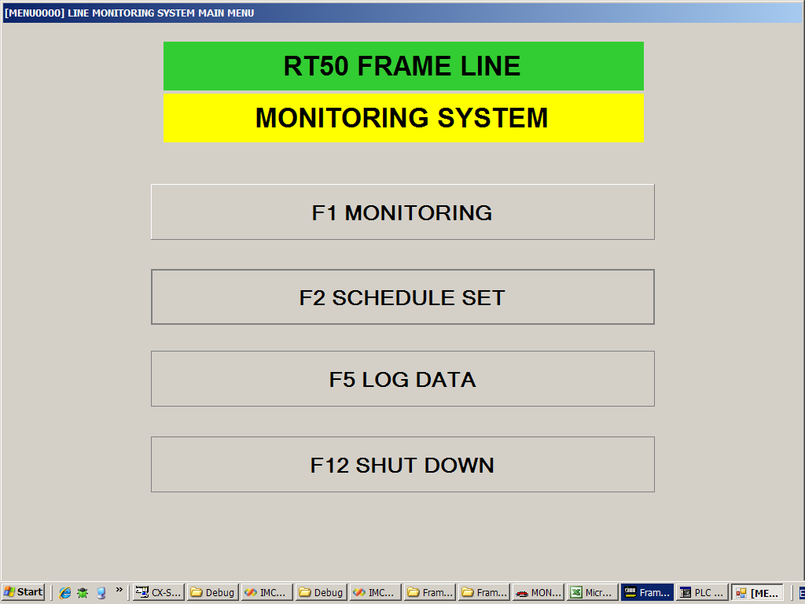
Figure 3-2 Main Menu

Monitoring | Open the Monitoring screen for display the line status and alarm, or actual result of production unit data  (click this button or press key F1)
Schedule Set | Open the Schedule Set screen for import plan, setting the pattern  (click this button or press key F2)
Log Data | Open the Log Data screen for show the production result or alarm report.  (click this button or press key F5)
Shut Down | Exit This Program  (click this button or press key F12)

Shut Down the System
From Main Menu click the button

Or press function key F12. The Shut Down menu will be shown as Figure 3-3
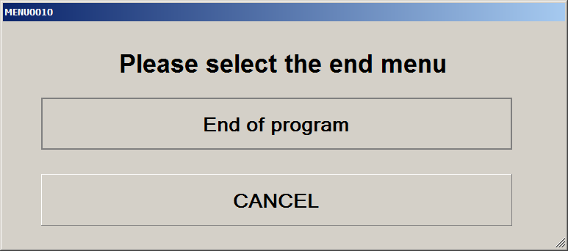
Figure 3-3 Shut Down Menu
Click the End of program button for end program
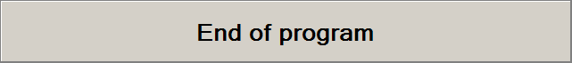
Or click the cancel button for back to main menu


LMS Client – Monitoring

Description
Monitoring screen shows the line equipment status both overall view of all lines or separate details in each lines.
The Frame Line Production will be separate to six lines as follows
- CPT Line
- M/A Line
- M/C Line
- S-M/A Line
- S-M/B Line
- S-M/C Line
- FATS Line
Screen of monitoring can show in the below list
- Show the overall view, which show all six lines of the Frame Line system. This screen shows only the status of States and Robot. The status was classified by the following colors
  - Auto Running (GREEN color)
  - Alarm (YELLOW color)
  - Fault (RED color)
  - Other / Cannot Defined (WHITE color)
  - Disabled (GRAY color)
  - Last 30 occurring alarms from all lines in the combo box at bottom of screen
- Show Details of CPT Line, M/A Line, M/C Line, S-M/A Line, S-M/B Line and S-M/C Line which contains the
  - Status of Lifters (Classified by color)
  - Status of States (Classified by color)
  - Status of Robots (Classified by color)
  - Status of O/H (Classified by color) -- only CPT, M/A, M/C line
  - Sequence Number in each states
  - Alarm occurring List
- Show the Actual Production Unit Data

From the Main Menu screen, open the Monitoring screen by click the button

Or press function key F1. The Monitoring screen will be shown for the first time default is the all line screen, as Figure 4-1

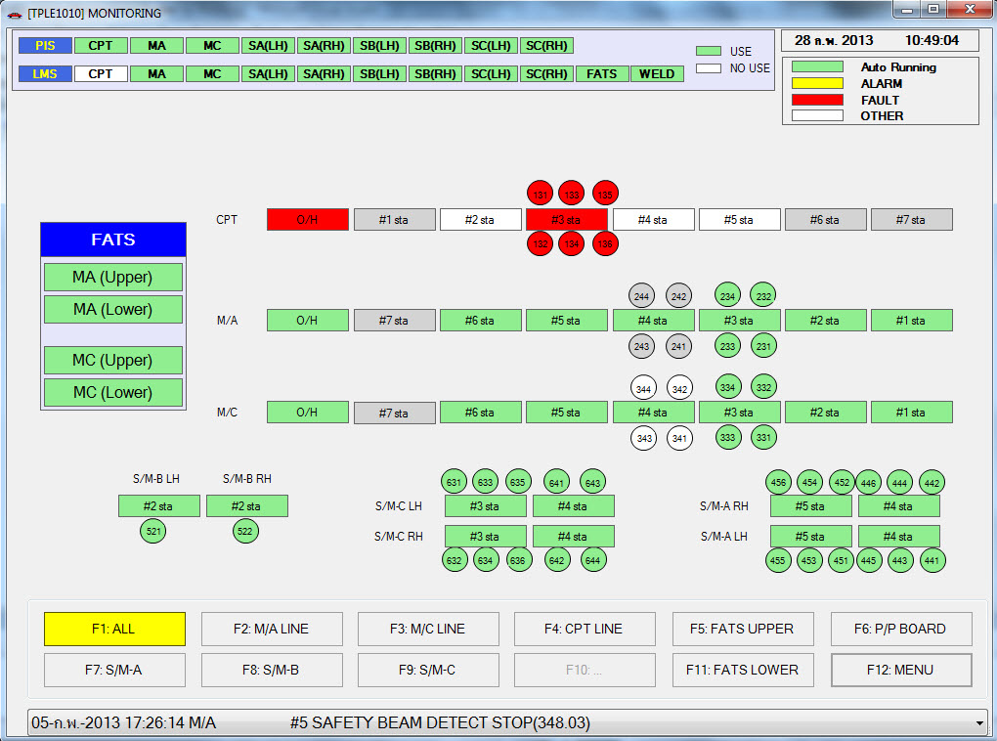
Figure 4-1 Monitoring screen – All-Lines screen

At the top-right of ALL-Lines monitoring screen show the current date and time and follow by the color status as below
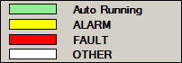

Switch to the other monitoring screen
At the bottom of screen has the group of buttons as below.
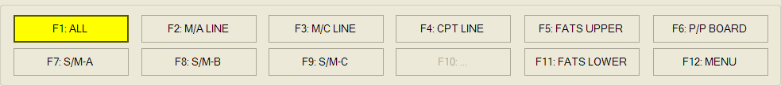

User can switch to other screen by click these buttons or press the function key.
 | Open All-Lines monitoring screen  (click this button or press key F1)
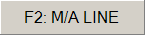 | Open details of M/A line monitoring screen  (click this button or press key F2)
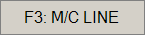 | Open details of M/C line monitoring screen  (click this button or press key F3)
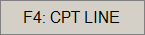 | Open details of CPT line monitoring screen  (click this button or press key F4)
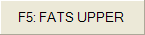 | Open details of FATS Upper line monitoring screen  (click this button or press key F5)
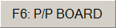 | Open Production Board screen  (click this button or press key F6)
 | Open details of S-M/A line monitoring screen  (click this button or press key F7)
 | Open details of S-M/B line monitoring screen  (click this button or press key F8)
 | Open details of S-M/C line monitoring screen  (click this button or press key F9)
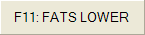 | Open details of FATS Lower line monitoring screen  (click this button or press key F11)
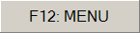 | Back to main menu  (click this button or press key F12)
After select in each button – or press function key – the selected button will shown in YELLOW color, another will shown in default color.

ALL-Lines Monitoring Screen
ALL-Lines monitoring screen is the default screen shown after user select from main menu. This screen shows all of equipments in overall view which show only the status of states and robots. For more details in each lines user can select in each line by click the buttons at the below screen or press function key, see Figure 4-1.

Use or No Use Status
At the top of ALL-Lines monitoring screen shows the status of USE or NO Use of each line, both PIS and LMS system. In case of USE status is active the box will show in GREEN color, otherwise show the WHITE. This screen portion will be shown in the top of all details monitoring screens.

FATS Status
At the left side of the middle screen show the status of FATS status of MA(Upper), MA (Lower), MC(Upper) and MC(Lower) as the box below.
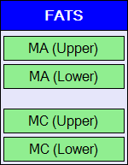
At the bottom of ALL-Lines monitoring screen will show the last 30 alarm occurring items in the combo box. In this list shown only the date and time occurring, Line, State and Alarm Description and Below
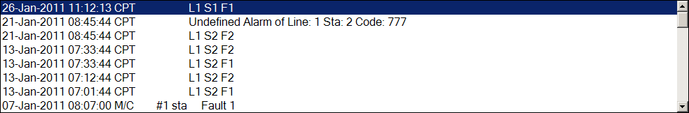

CPT Line Monitoring Screen
In any Monitoring screen, user can see the details of CPT Line Monitoring screen by click the button or press F4. The CPT Line Monitoring screen will be shown as Figure 4-2.
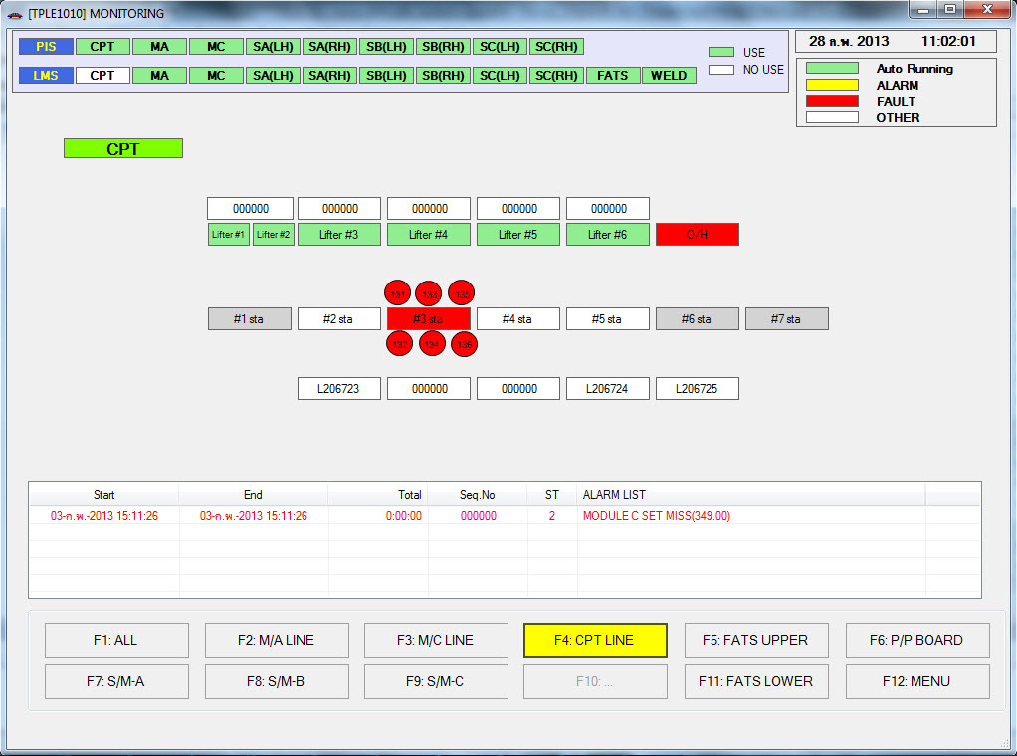
Figure 4-2 CPT Line Monitoring Screen
In details of this monitoring screen shows the following items
- status of States (classified status by color)
- status of Lifter (classified status by color)
- status of O/H (classified status by color)
- status of Robots (classified status by color)
- Sequence Number in each States
- Details of alarm occurring which contains Start Time, End Time, Total Time, Sequence Number, State Number and Alarm Description

M/A Line Monitoring Screen
In any Monitoring screen, user can see the details of M/A Line Monitoring screen by click the button or press F2. The M/A Line Monitoring screen will be shown as Figure 4-3.
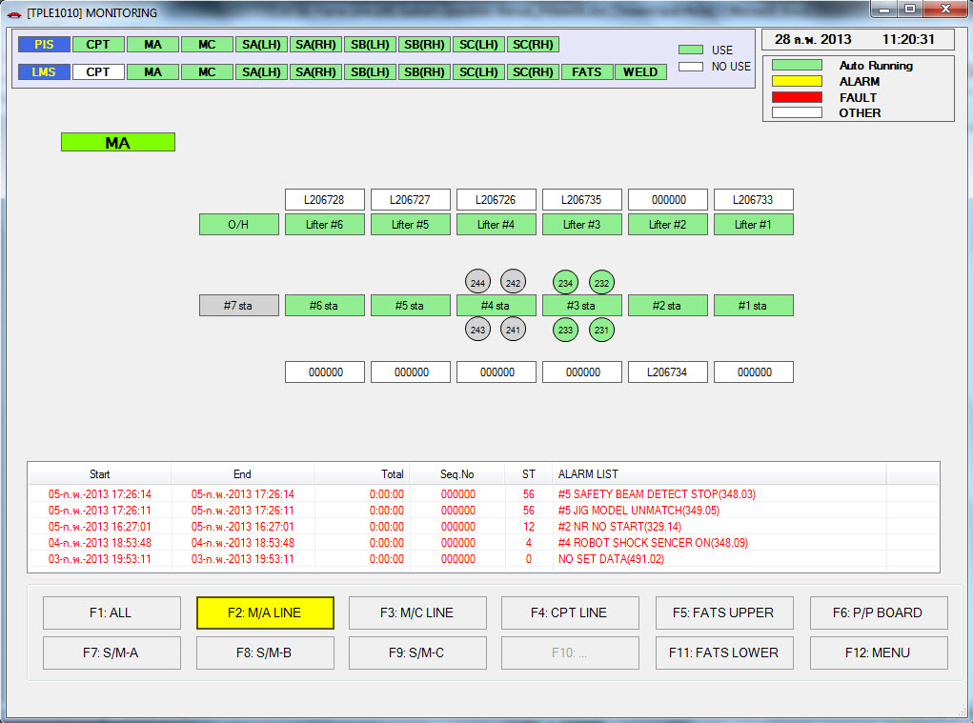
Figure 4-3 M/A Line Monitoring Screen
In details this Monitoring screen shows the following items
- status of States (classified status by color)
- status of Lifter (classified status by color)
- status of O/H (classified status by color)
- status of Robots (classified status by color)
- Sequence Number in each States
- Details of alarm occurring which contains Start Time, End Time, Total Time, Sequence Number, State Number and Alarm Description

M/C Line Monitoring Screen
In any Monitoring screen, user can see the details of M/C Line Monitoring screen by click the button or press F3. The M/C Line Monitoring screen will be shown as Figure 4-4.
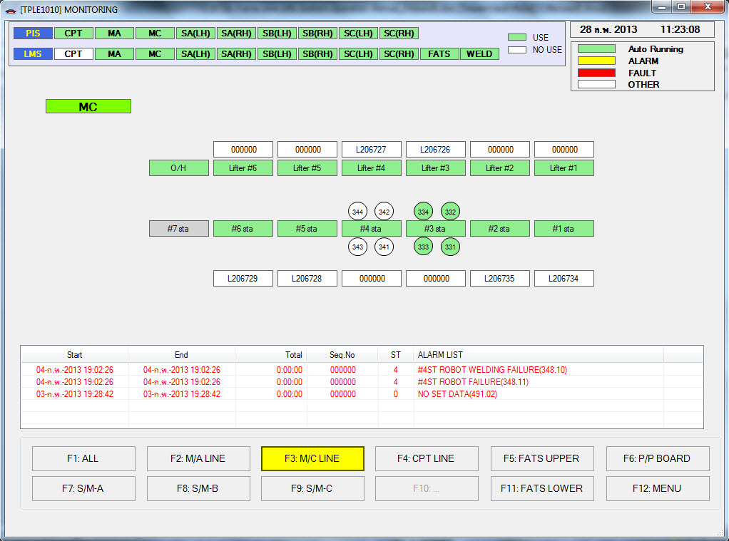
Figure 4-4 M/C Line Monitoring Screen
In details this Monitoring screen shows the following items
- status of States (classified status by color)
- status of Lifter (classified status by color)
- status of O/H (classified status by color)
- status of Robots (classified status by color)
- Sequence Number in each States
- Details of alarm occurring which contains Start Time, End Time, Total Time, Sequence Number, State Number and Alarm Description

S-M/A Line Monitoring Screen
In any Monitoring screen, user can see the details of S-M/A Line Monitoring screen by click the button or press F7. The S-M/A Line Monitoring screen will be shown as Figure 4-5.
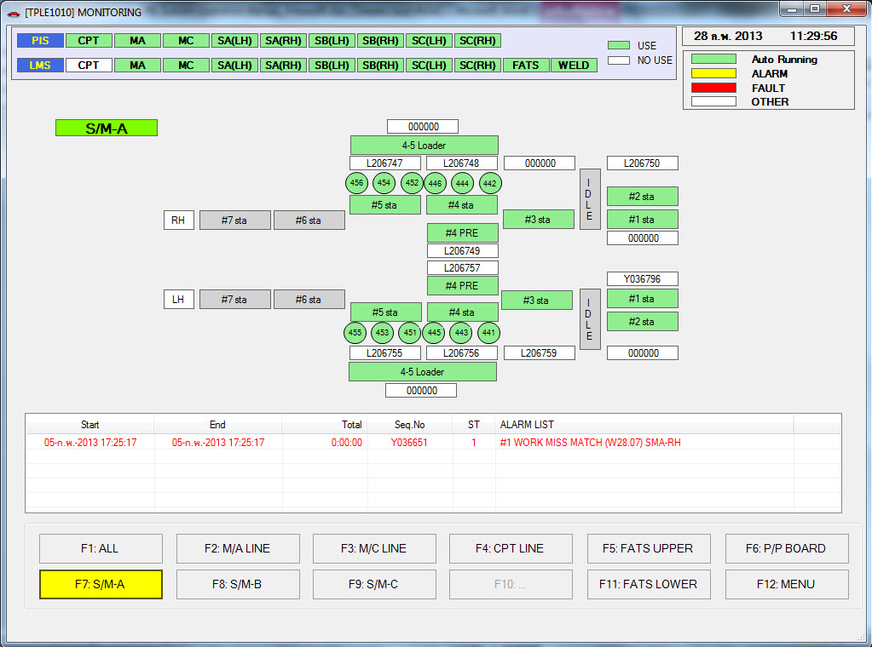
Figure 4-5 S-M/A Line Monitoring Screen
In details this Monitoring screen shows the following items
- status of States (classified status by color)
- status of Robots (classified status by color)
- Sequence Number in each States
- Details of alarm occurring which contains Start Time, End Time, Total Time, Sequence Number, State Number and Alarm Description

S-M/B Line Monitoring Screen
In any Monitoring screen, user can see the details of S-M/B Line Monitoring screen by click the button or press F8. The S-M/B Line Monitoring screen will be shown as Figure 4-6.
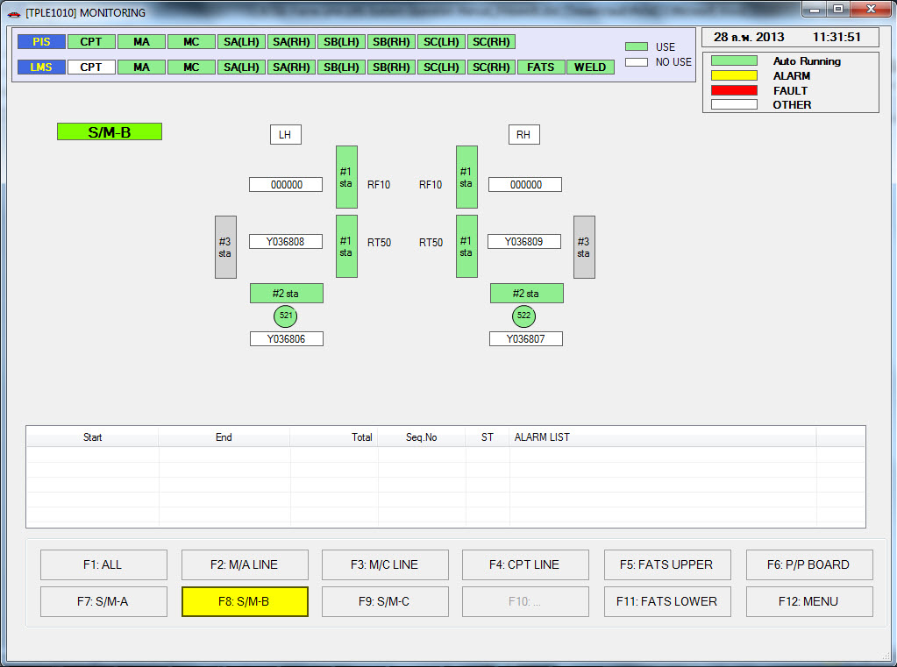
Figure 4-6 S-M/B Line Monitoring Screen
In details this Monitoring screen shows the following items
- status of States (classified status by color)
- status of Robots (classified status by color)
- Sequence Number in each States
- Details of alarm occurring which contains Start Time, End Time, Total Time, Sequence Number, State Number and Alarm Description

S-M/C Line Monitoring Screen
In any Monitoring screen, user can see the details of S-M/C Line Monitoring screen by click the button or press F9. The S-M/B Line Monitoring screen will be shown as Figure 4-7.
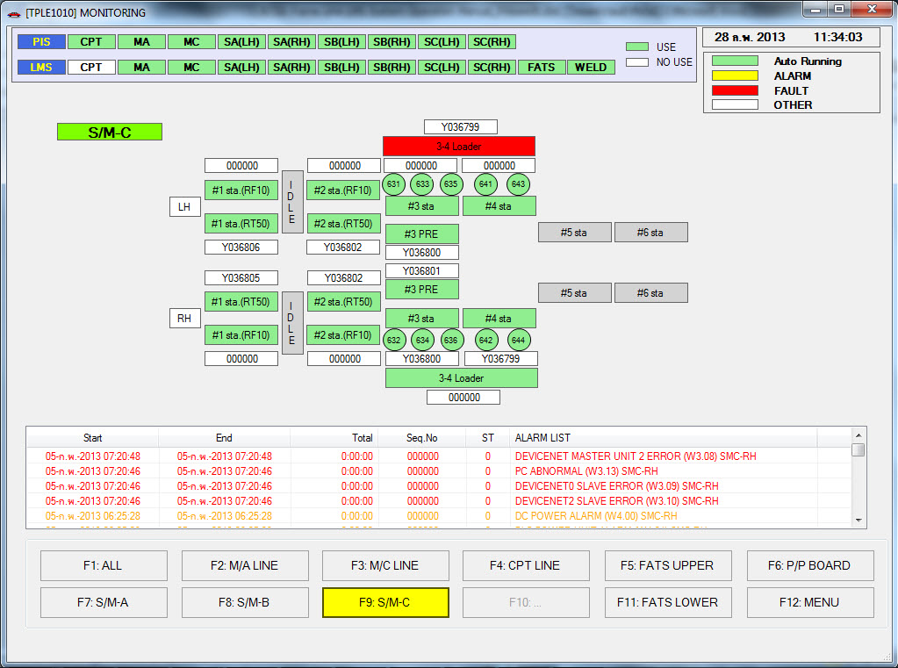
Figure 4-7 S-M/C Line Monitoring Screen
In details this Monitoring screen shows the following items
- status of States (classified status by color)
- status of Robots (classified status by color)
- Sequence Number in each States
- Details of alarm occurring which contains Start Time, End Time, Total Time, Sequence Number, State Number and Alarm Description

FATS Upper Monitoring Screen
In any Monitoring screen, user can see the details of FATS Upper Monitoring screen by click the button or press F5. The FATS Upper Monitoring screen will be shown as Figure 4-8.
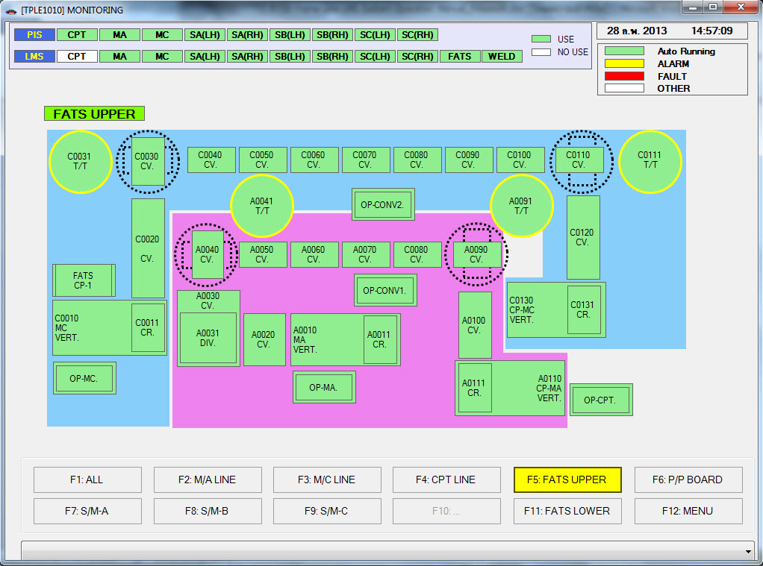
Figure 4-8 FATS Upper Monitoring Screen
In details this Monitoring screen shows the following items
- status of CV
- Status of VERT.
- status of FATS
- status of OP
- Status of T/T
- List of Alarm of FATS Line in the combo box at the bottom of screen

FATS Lower Monitoring Screen
In any Monitoring screen, user can see the details of FATS Lower Monitoring screen by click the button or press F5. The FATS Lower Monitoring screen will be shown as Figure 4-8.
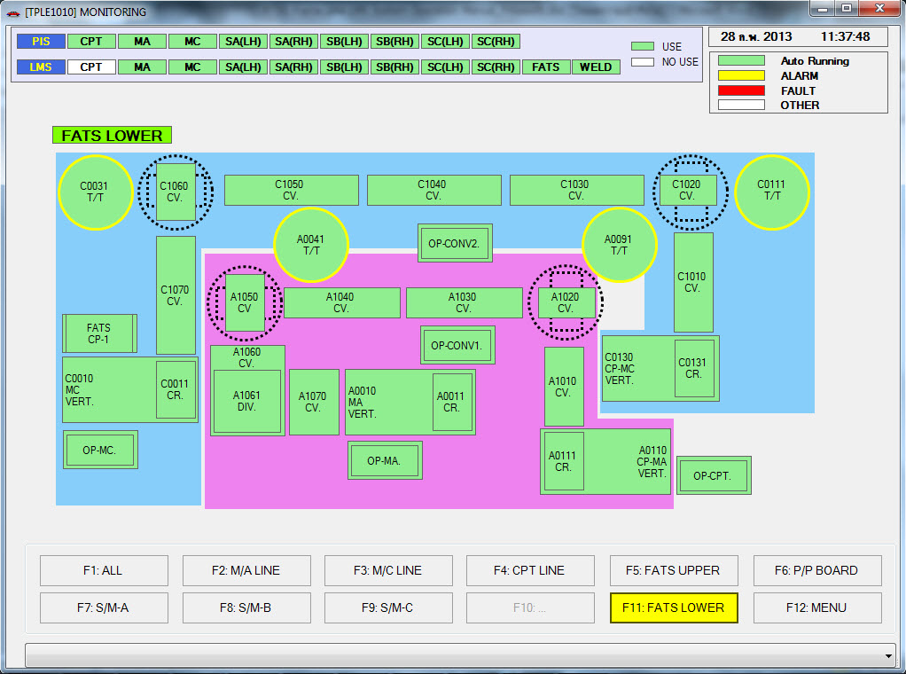
Figure 4-9 FATS Lower Monitoring Screen
In details this Monitoring screen shows the following items
- status of CV
- Status of VERT.
- status of FATS
- status of OP
- Status of T/T
- List of Alarm of FATS Line in the combo box at the bottom of screen

P/P Board Monitoring Screen
In any Monitoring screen, user can see the details of P/P Board Monitoring screen by click the button or press F6. The P/P Board Monitoring screen will be shown as Figure 4-8.
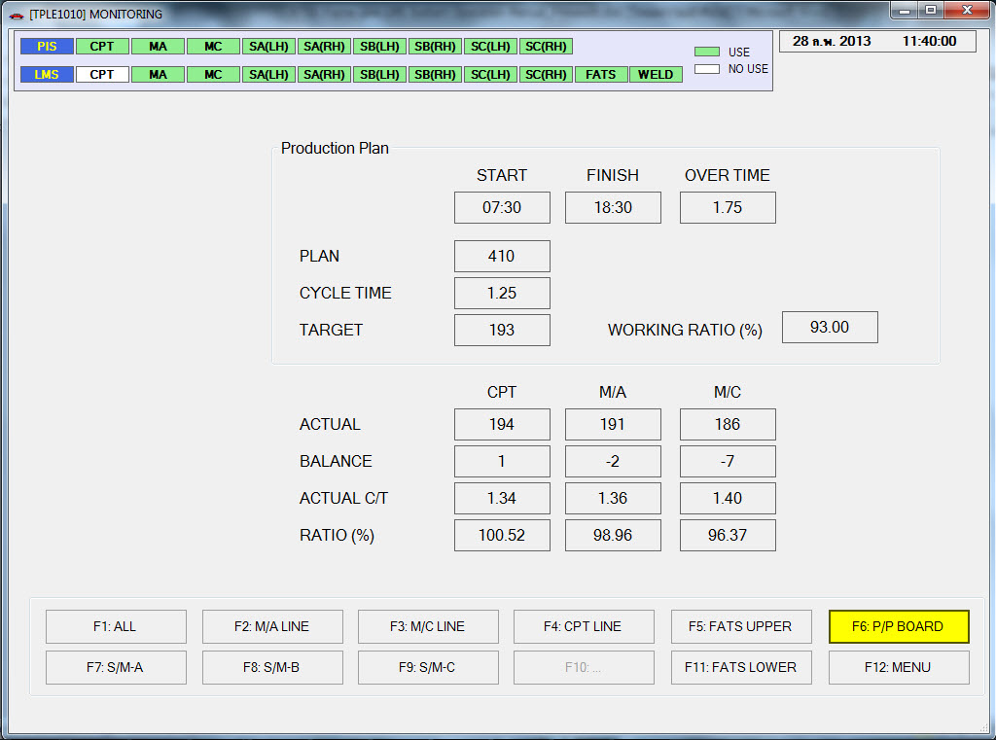
Figure 4-10 P/P Board Monitoring Screen

Back to Main Menu
Press the button or function key F12.

LMS Client – Schedule Set

Description
User can set the production plan, edit and set the production pattern by this screen.
Screen of Schedule Set can show in the below functions
- Show the Daily Production Plan, separate screen by month
- Import production plan from Ms. Excel File (Ms. Excel 2003) and fixed format of data.
- Edit plan
- Edit production pattern

From the Main Menu screen, open the Schedule Set screen by click the button
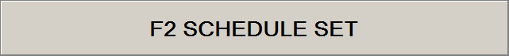
Or press function key F2. The Schedule Set screen will be shown for the first time default is the list of daily plan in current month, as Figure 5-1

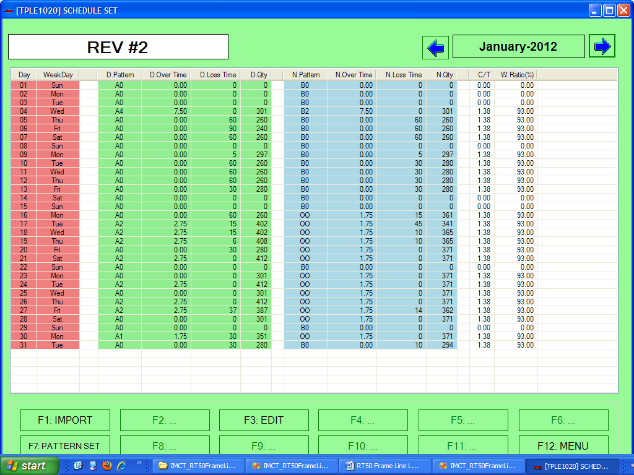

Figure 5-1 Schedule Set Screen

At the top-left of screen show the box of last time imported revision as below
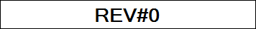
At the top-right of screen show the selected month – default is the current month/year – as below

User can click the  button for select previous month, or click the  button for next month.
Each line in the plan list shows the daily plan which contains the date, Day shift plan, Night shift plan and cycle time. For Day shift will highlight by GREEN background color, night shift highlight by BLUE background color. In case of day in the pass will be highlight by RED background color in date column.
The bottom of screen contains the function key as below
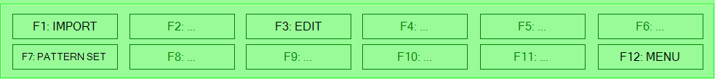
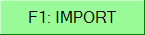 | Import Production Plan from Ms. Excel File  (click this button or press key F1)
 | Edit Production Plan  (click this button or press key F3)
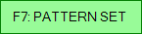 | Modify the Pattern Set  (click this button or press key F7)
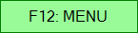 | Back to main menu  (click this button or press key F12)

Import Plan File
Import plan file from Ms. Excel data, the file format must be the Ms. Excel 2003 and fixed format of data. From the Schedule Set screen, click the button or press function key F1 the open file dialog will be shown as Figure 5-2
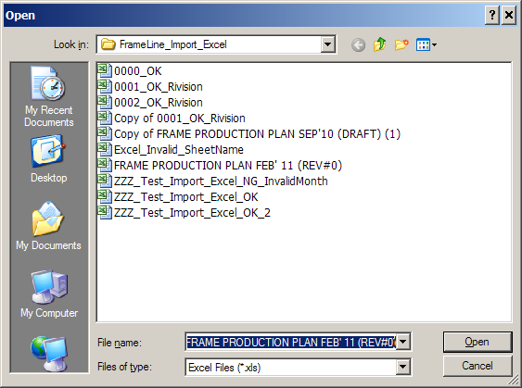
Figure 5-2 Dialog box ask for import file
After user select the file and click the button, program will perform import data from Ms. Excel file.
In case of import data which previous data is exists, program will show the below dialog for warning user and ask for confirmation
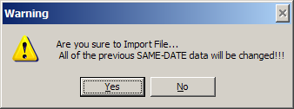
Click button for confirm.
For protect the old data, in case of import data in the current month, only the current date and after will be imported. The day in the past cannot import into database.
After import success, the dialog will be shown as below
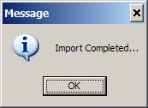

In any cases of failure from import file the follow dialog will be shown
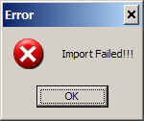

Import file conditions
- Import file must be the Ms. Excel 2003 format
- The import file must be exists
- The Ms. Excel file must contain valid sheet name -- “No1Line”
- The data of Month and Year must same as the selected month and year on the screen (in cell A1)
- The details of data must be fixed position in row and column

Edit Plan
Production plan after import from Ms. Excel file user can modify the day-by-day plan. From the Schedule Set screen select ONE item in the plan list for edit and click the button or press function key F3 the Daily Schedule Screen will be shown as Figure 5-3

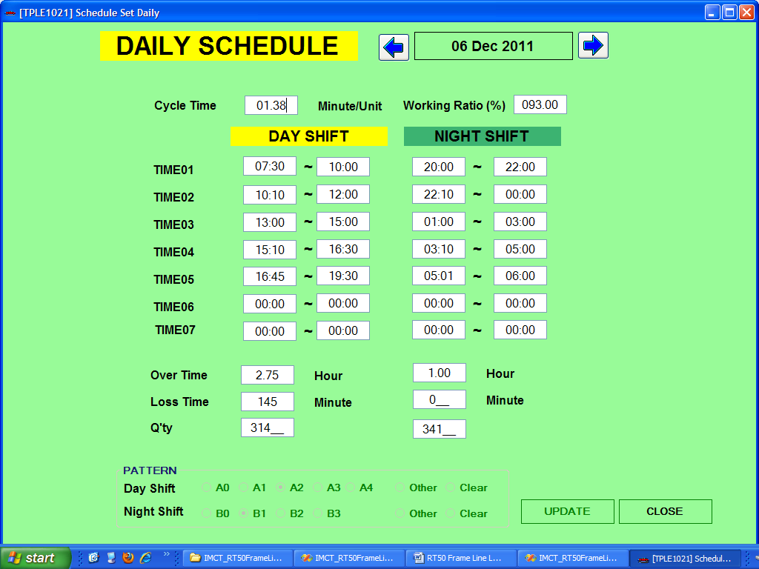
Figure 5-3 Daily Schedule Plan Screen

At the top-right of screen show the selected date  and the below contain the plan details. User can click button  for previous date or button  for next date.

Pre-Set Pattern
The below screen user can select the pre-set pattern of Day-Shift and Night Shift
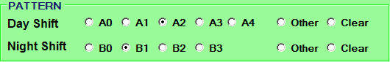
Day Shift includes A0, A1, A2, A3 and A4
Night Shift includes B0, B1, B2 and B3

In case of select of select the pre-set pattern the details in above time01 to time07 must be change automatically by pattern.

In case of user want to set the other different from pre-set pattern, user can click the in Day or Night shift or both, and then edit the other above input details.
In case of user want to clear all input details, user can click the item in Day or Night shift or both. The confirmation dialog will be shown as below, for example click for clear the Day Shift
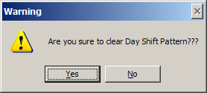
After click the button all of details of Day shift will be clear.

Save to Database
After edit the daily schedule and want to save into database click the  button, program will show the confirmation dialog as below
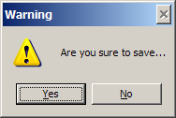
Click button for save new data, or click button for cancel.

Back to Schedule Set screen
Click the  button at the bottom-right of screen for back to Schedule Set Screen

Open Daily Schedule in the Past Date
In case of open the schedule in the past date, user cannot save data into database because the production data were already process. The screen will be shown as below
Figure 5-4 Daily Schedule Plan Screen for past date
See the bottom of screen the pre-set pattern cannot select and button is not activated, that means this screen can only show but cannot edit.

Pattern Set
User can set the pattern master -- both Day shift and Night shift
Day Shift: There are five pre-set pattern – A0, A1, A2, A3 and A4
Night Shift: There are four pre-set pattern – B0, B1, B2 and B3

From the Schedule Set click the button or press function key F7 the Working Time Screen will be shown as Figure 5-5

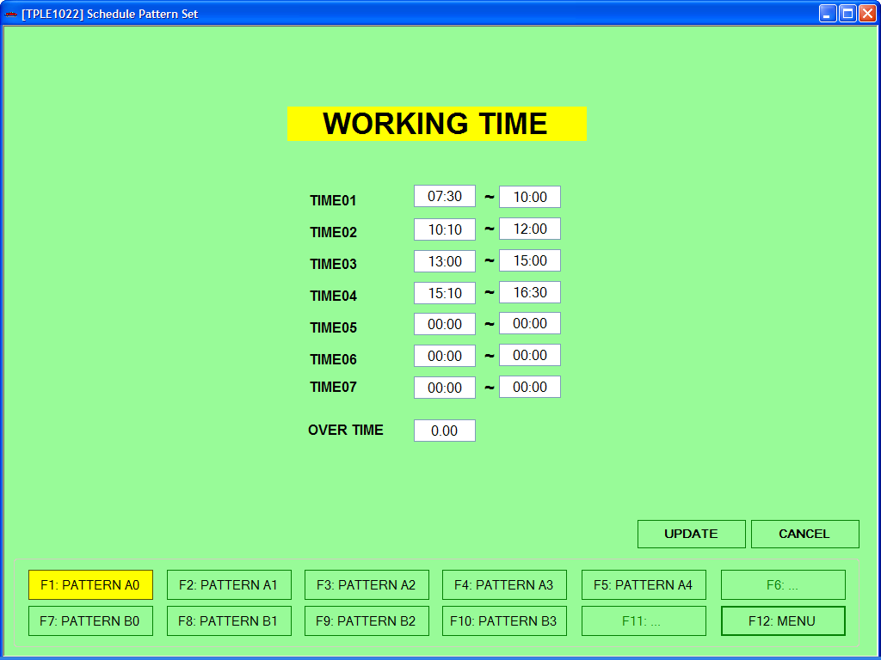
Figure 5-5 Working Time Screen for set the Pattern

At the below screen show the function key
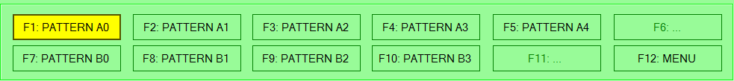

User can select the desired pattern for show details or edit pattern data by click the button or Function Key
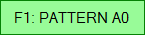 | Show Details or Edit Pattern A0  (click this button or press key F1)
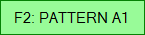 | Show Details or Edit Pattern A1  (click this button or press key F2)
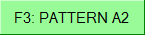 | Show Details or Edit Pattern A2  (click this button or press key F3)
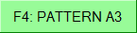 | Show Details or Edit Pattern A3  (click this button or press key F4)
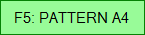 | Show Details or Edit Pattern A4  (click this button or press key F5)
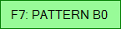 | Show Details or Edit Pattern B0  (click this button or press key F7)
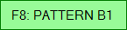 | Show Details or Edit Pattern B1  (click this button or press key F8)
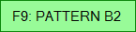 | Show Details or Edit Pattern B2  (click this button or press key F9)
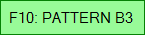 | Show Details or Edit Pattern B3  (click this button or press key F10)
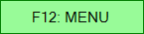 | Back to Schedule Set Screen  (click this button or press key F12)
In case of select each pattern the button will be indicated by YELLOW button, other is the default color button.

Save Change the Pattern
After edit the Time and/or Overtime input data and want to save into database click the button for save change. The program will show the below confirmation dialog.
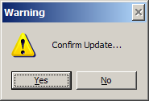
Click button for save change, or button to cancel.

Cancel Change the Pattern
After edit the Time and/or Overtime input data and want to cancel and back to previous data click the  button for cancel change. The program will show the below confirmation dialog.
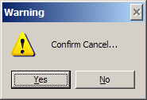
Click button for save change, or button to cancel.

LMS Client – Log Data

Description
Show the report from the production result and alarm data
Screen of Log Data can show in the below functions
- Show and Export of the Alarm data in Daily, Weekly and Monthly
- Show and Export of the Welding data in Daily, Weekly and Monthly
- Show and Export of the Production Result List in Monthly

From the Main Menu screen, open the Log Data screen by click the button

Or press function key F5. The Log Data screen will be shown for the first time default is the list of daily plan in current month, as Figure 6-1

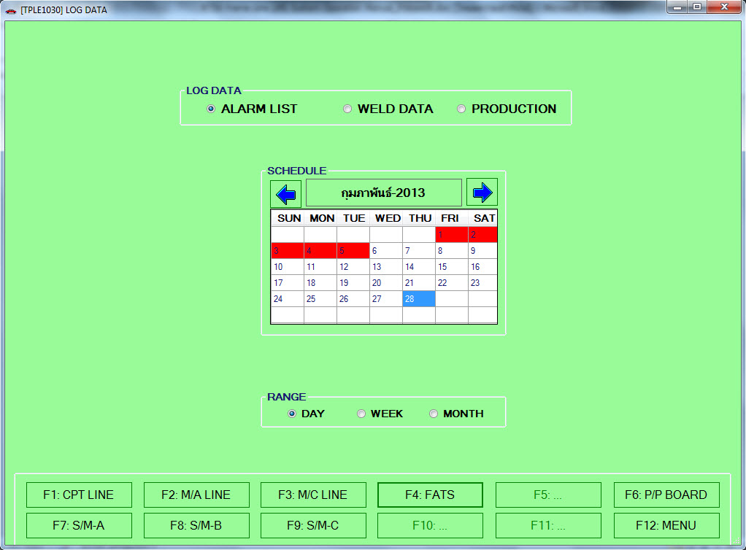

Figure 6-1 Log Data Screen

At the above screen select type of report
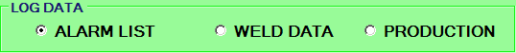

Show Alarm List Report
Select this item the below calendar will show RED color in date that has alarm occurs
Show Weld Data Report
Select this item the below calendar will show YELLOW color in date that has welding data
Show Production Report
Select this item the below calendar will show the below
- GREEN color in date that has already production
- YELLOW color, case of holiday
- WHTIE color, other case

Then Select the Date in the calendar
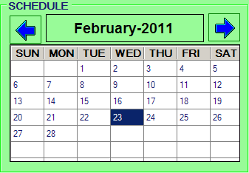
Previous Month
Next Month
Default Current Date
Select the Time Period
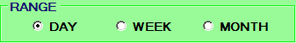

Report only selected Date
Report from SUN to SAT of selected Date
Report from 1 to end of month of selected Date

At the bottom of screen select the production line for show report

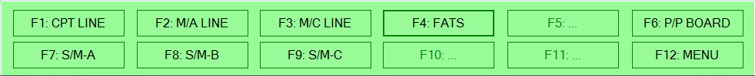

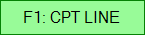 | Report of CPT Line (Only Alarm or Welding Data)  (click this button or press key F1)
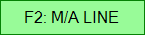 | Report of M/A Line (Only Alarm or Welding Data)  (click this button or press key F2)
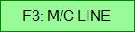 | Report of M/C Line (Only Alarm or Welding Data)  (click this button or press key F3)
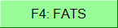 | Reports of FATS Line (Only Alarm)  (click this button or press key F4)
 | Report of S/M-A Line (Only Alarm or Welding Data)  (click this button or press key F7)
 | Report of S/M-B Line (Only Alarm or Welding Data)  (click this button or press key F8)
 | Report of S/M-C Line (Only Alarm or Welding Data)  (click this button or press key F9)
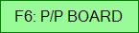 | Report of P/P Board (Monthly Report)  (click this button or press key F6)
 | Back to Main Menu

Alarm List Report
When user select the item of , select calendar date, range and select the production line. The Alarm List Report will be shown as Figure 6-2
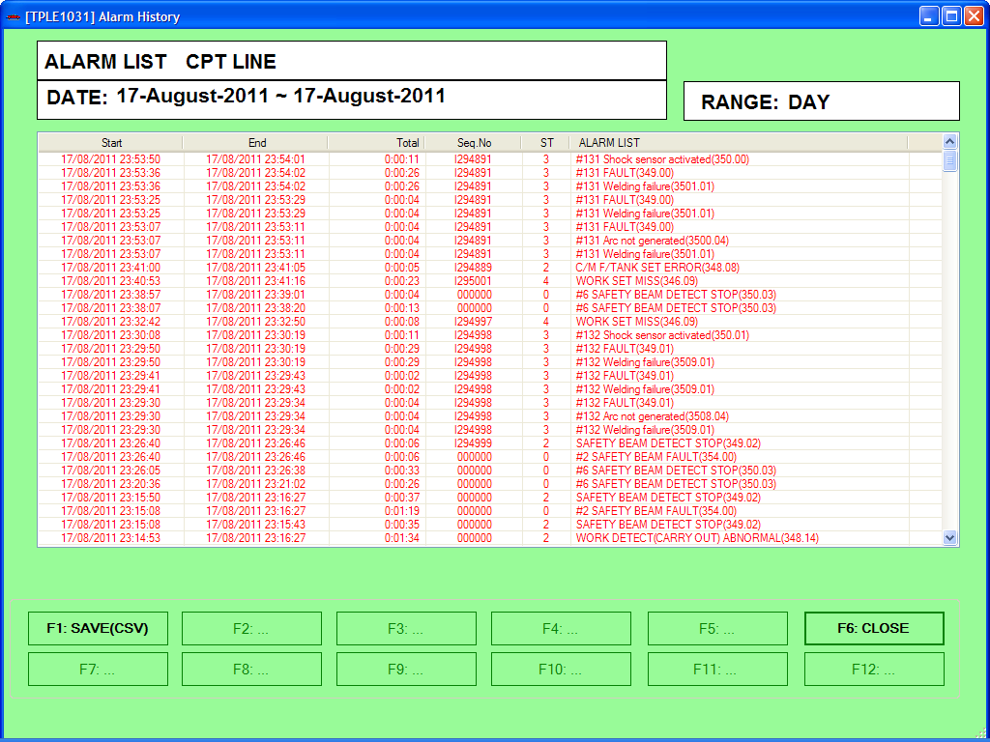
Figure 6-2 Alarm List Screen

At the above screen show the Line Name, Date and Range type of Selection. Then follow by the details of alarm includes Start Time, End Time, Total Time, Sequence Number, State Number and Alarm List Description.

At the bottom screen show the function key
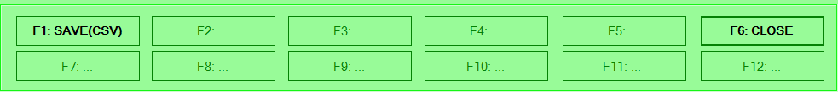

In case of press 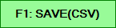 button, or press function key F1, for export data in the above list into CSV file format. The save dialog will be show as below
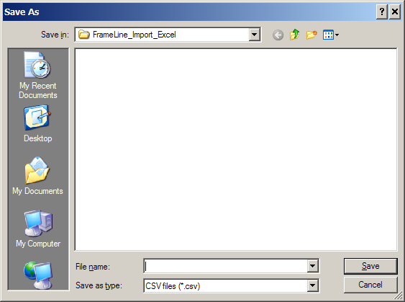

After select the destination folder and filename click button, program will perform export data into CSV file format and show the below information dialog.
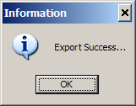

Back to Log Data Screen
Press the  button or press function key F6

Welding Data Report
When user select the item of in Figure 6-3, user can choose to save log or not. Then select calendar date, range and select the production line. The Welding Data Report will be shown as Figure 6-4

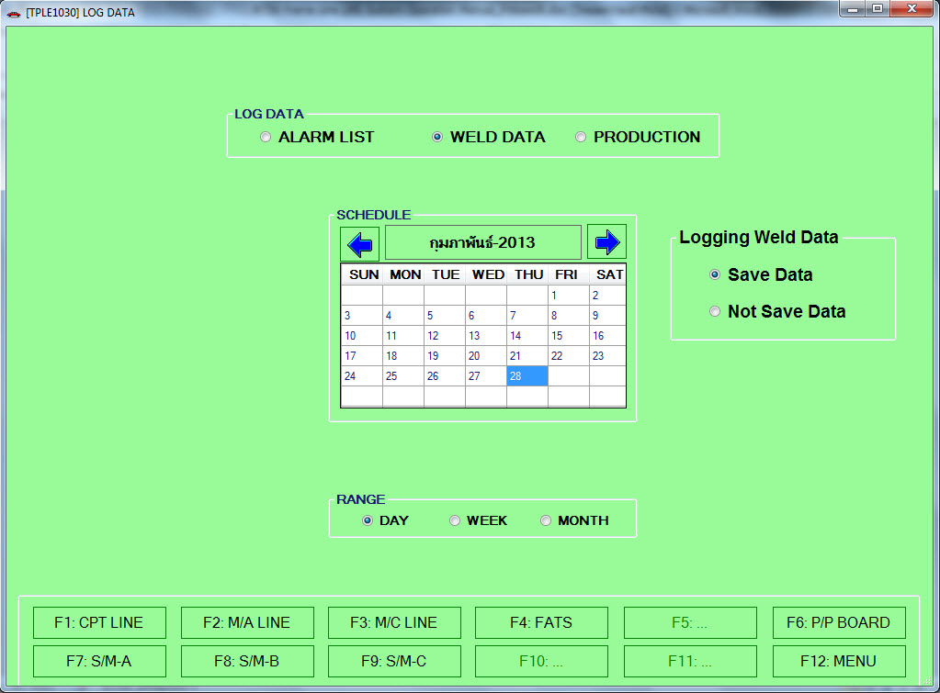
Figure 6-3 Main Welding Data Screen

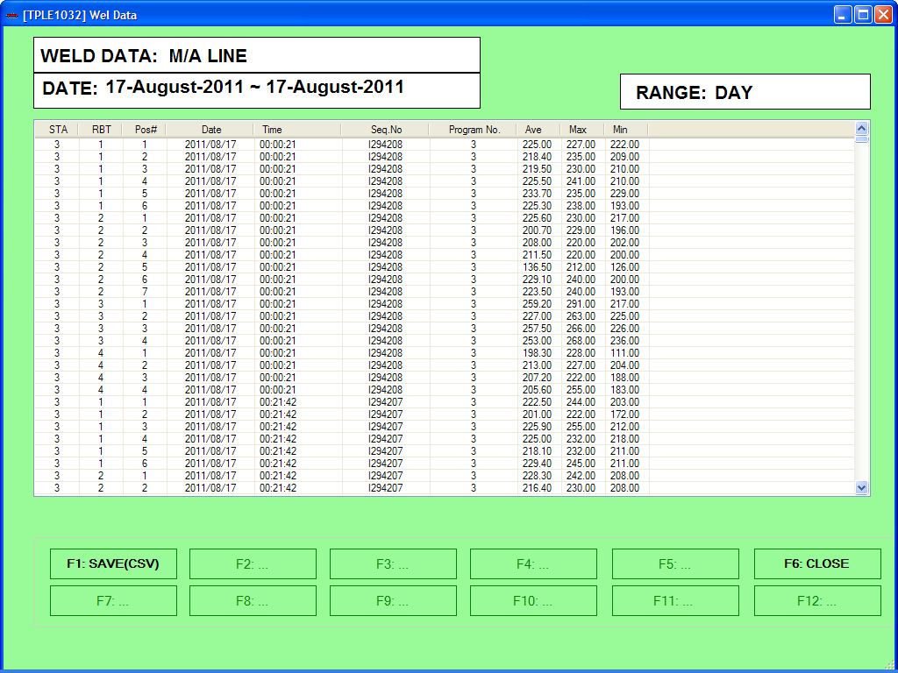

Figure 6-4 Welding Data Screen

At the above screen show the State Number, Robot Number, Position Number, Date, Time, Sequence Number, Program Number, Average Value, Max Value and Min Value.

At the bottom screen show the function key

In case of press button, or press function key F1, for export data in the above list into CSV file format. The save dialog will be show as below

After select the destination folder and filename click button, program will perform export data into CSV file format and show the below information dialog.

Back to Log Data Screen
Press the button or press function key F6

P/P Board Report
When user select the item of , select calendar date, range and select the button. The P/P Board Report will be shown as Figure 6-5
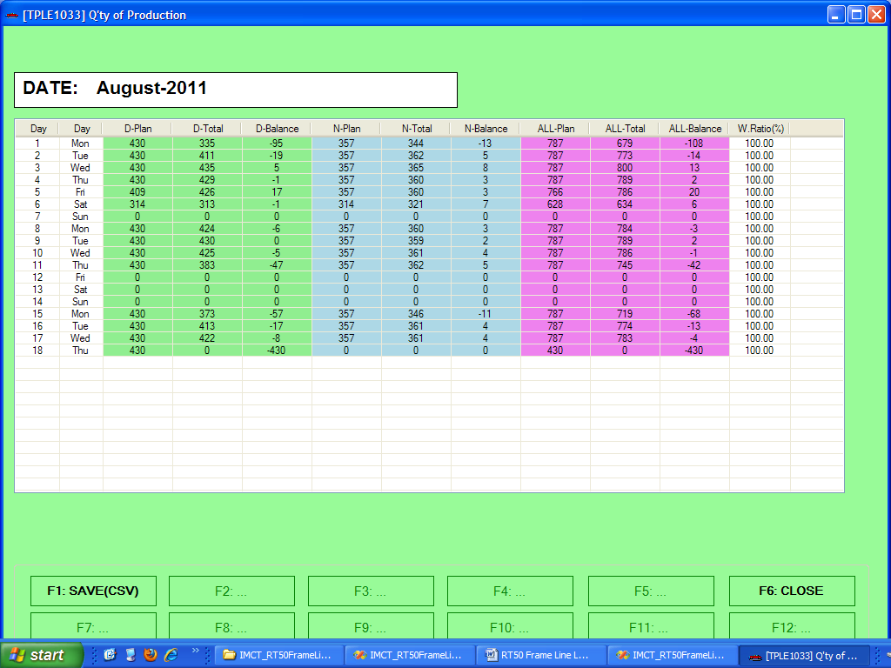
Figure 6-5 P/P Board Report

At the above screen show the Date, Day of week, Day Shift Plan, Day Shift Total, Day Shift Difference, Night Shift Plan, Night Total, Night Shift Different, All-Day Plan, All-Day Total and All-Day Different.

At the bottom screen show the function key

In case of press button, or press function key F1, for export data in the above list into CSV file format. The save dialog will be show as below

After select the destination folder and filename click button, program will perform export data into CSV file format and show the below information dialog.

Back to Log Data Screen
Press the button or press function key F6

